PCB manufacturing request form for quotation :

General informations :
PCB Designation : MatchX_mx231x_V1.1  Manufacturer :  Contact name :  E-Mail :  Phone :  Fax : | MatchX GmbH  Oberwallstraße 6, 10117 Berlin  Contact :  Phone :  Fax :  Date :
Technical Data :
Existing circuit No Lead time :
Yes (Original date) Quantity : 5 pieces
Circuit dimensions : length : 175.5 mm, width : 107 mm
PCB description :
Silkscreen Top side Yes No yellow white
Solder mask Top side Yes No Colour : Green
Number of copper layers : 4
Solder mask Bottom side : Yes No Colour : Green
Silkscreen Bottom side : Yes No yellow white
Paste mask Yes No Only gerbers Only film
Glue mask Yes No Only gerbers Only film
Minimum distance between tracks : 0.127 mm Minimum track width : 0.127 mm
Holes metalized (PTH) : Yes
Components : SMD 1 side 2 sides
External copper thickness : 35 μm (standard), 70 μm, 105 μm
Internal copper thickness : 18 μm (standard), 35 μm, 70 μm
Material type : FR4 (temp max.135°C) FR4 (temp max.175°C) G30 Other :
Thickness : 0.5mm 0.8mm 1.0mm 1.2mm 1.6mm (standard) 2.0mm other :
Surface treatment : Drilling :
Immersion Gold ∅ Smallest hole: 0.25 mm
Chemical plating Ni/Au ∅ Largest hole : 3.25mm
Contacts plating : cm² Total number of holes : 1525
Number of tools : 12
Mechanical treatment :
CNC-machine tooled according to plan Scoring
Metalized slot according to drilling plan Routed with pips
Milling diameter max. : mm Vias covered by Solder Mask

Additionnal request :
Electrical tests
。 extended Gerber (RS274x)

阻抗控制注意：

Stack up

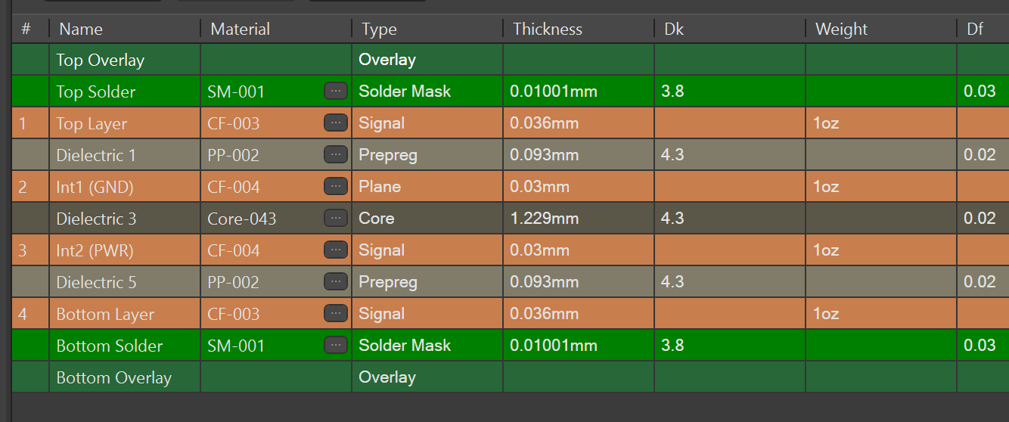

90 Ohm differential (layer 1) to (Layer 2) as a reference plane
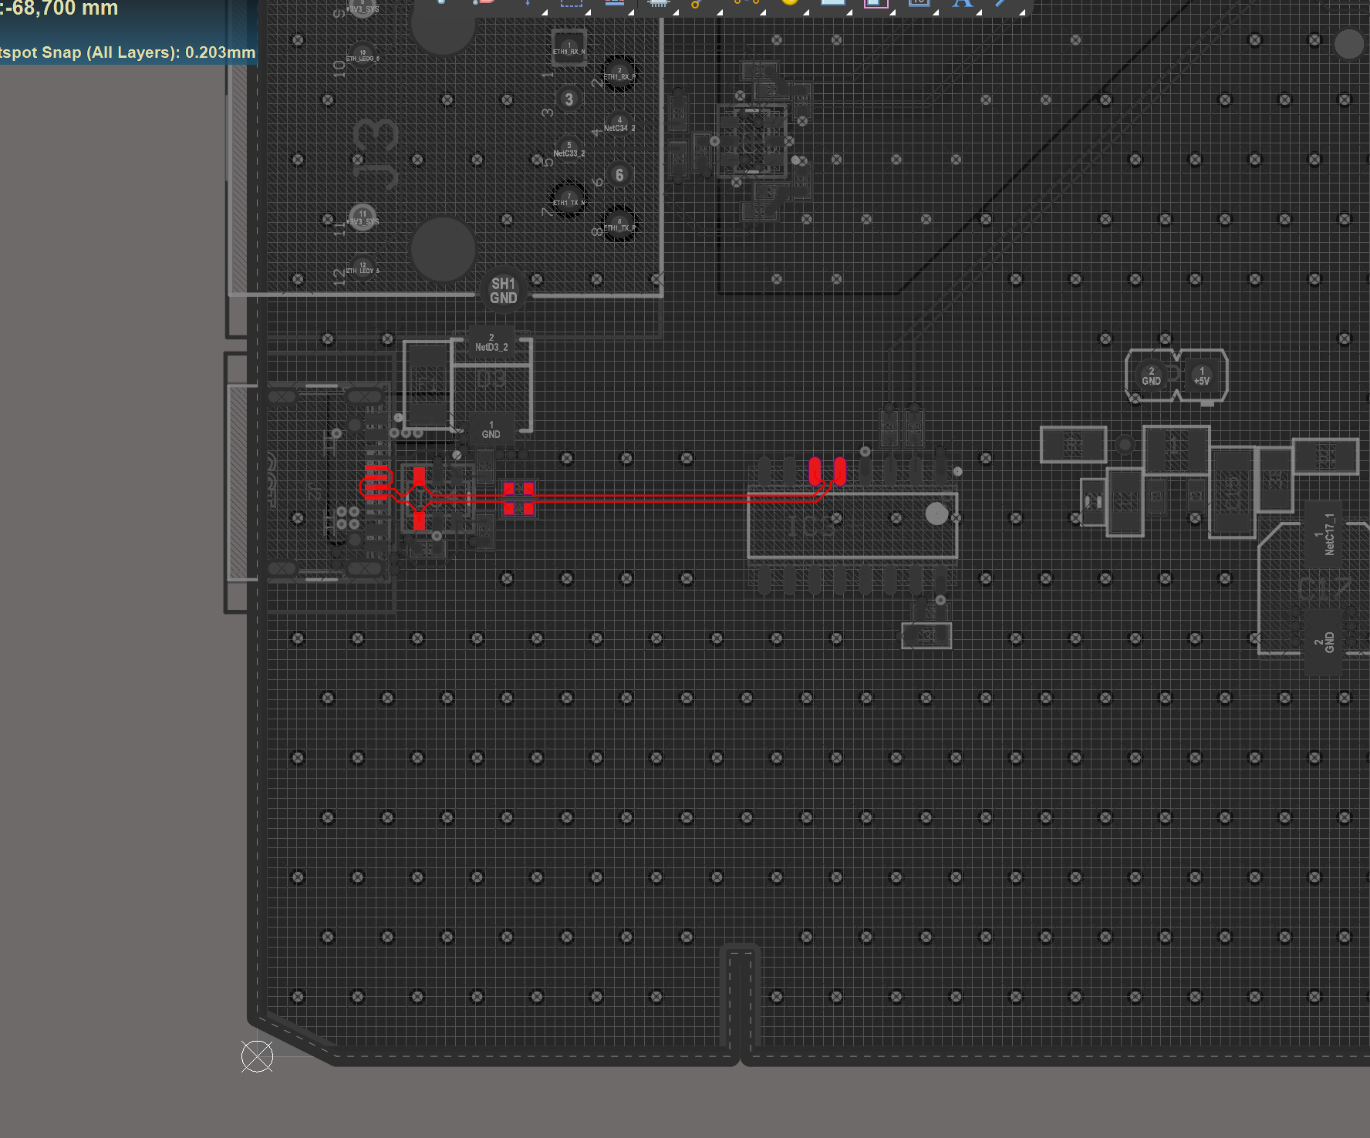

100 Ohm differential (layer 1) to (Layer 2) as a reference plane
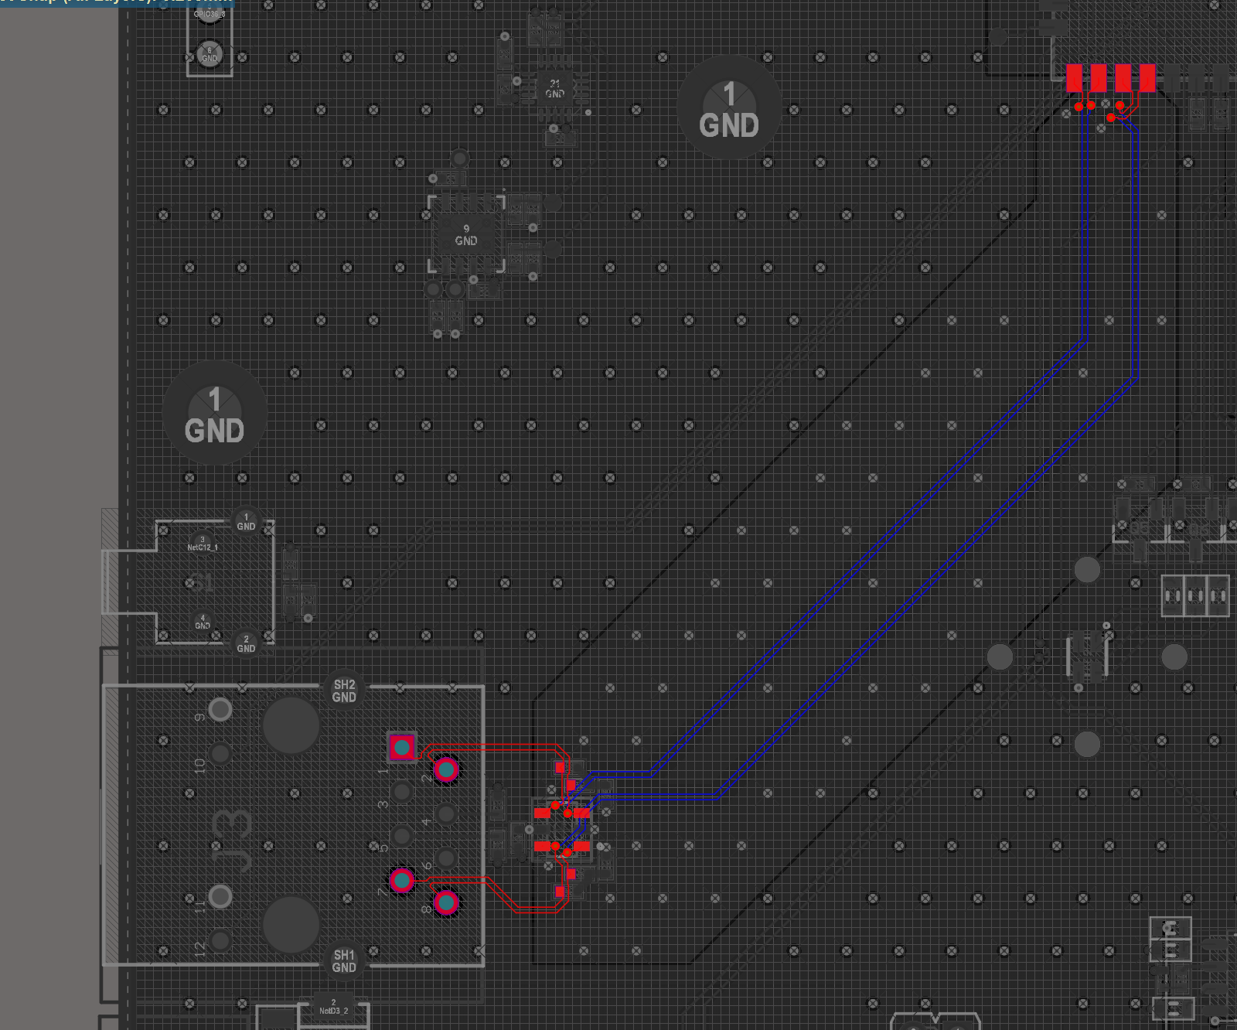

100 Ohm differential (layer 4) to (Layer 3) as a reference plane

Coplanar 50 Ohm (layer 1) to (Layer 3) as a reference plane.

